UNIVERSITY OF CENTRAL PUNJAB
Faculty of Information Technology and Computer Science

Information Security
Assignment No. 01
Packet Sniffing Application Using libpcap

Submitted by
1. Name: Syed Nouman Haider Registration No.: L1F23BSSE0216
2. Name: Syed Danyal Gillani Registration No.: L1F23BSSE0370
3. Name: Muhammad Burhan Registration No.: L1F23BSSE0387
4. Name: Fizza Zubair Registration No.: L1F23BSSE0293
5. Name: Fatima Batool Registration No.: L1F23BSSE0049

Section: G2
Assignment date: 13 October 2026
Submission date: 20 October 2026

1. Introduction
For this assignment, we developed a basic packet sniffer in C using the libpcap library. The purpose is to capture network packets and read the information stored in their headers. Our program first displays the packet bytes in hexadecimal form and then prints the Ethernet, IPv4 and TCP or UDP fields in order. This helps us see how information is arranged across the different network layers.
We used manual byte indexing instead of the ready-made header structures. It required us to work with offsets, bitwise operators and network byte order, especially while reading fields that occupy more than one byte. The testing shown later was carried out on our own computer.

2. Tools and Setup
The program is written in C and uses libpcap to access packet data from a network interface. We tested the program in the macOS Terminal using the Wi-Fi interface en0 and the Clang compiler. The same source is intended for a Linux/Ubuntu environment with libpcap installed, as required in the assignment, but the screenshots in this report are from the Mac test.
We used the C compiler to build the program, libpcap for live packet capture, and the Terminal to run and test it. For our macOS test, the active Wi-Fi interface was en0.

3. Working of the Program
The execution starts in main(). The program accepts an interface name from the command line. If no interface is supplied, it attempts to select one with pcap_lookupdev(). Next, pcap_open_live() opens that device for capturing. We set the snapshot length to 2048 bytes, request promiscuous mode, and provide a 1000 ms capture timeout. The program checks that the selected interface provides Ethernet-style frames.
After that, pcap_loop() keeps capturing packets and calls process_pkt() for each one. In the callback, we print the hex dump before reading any headers. The first 14 bytes are treated as the Ethernet header. If the EtherType is 0x0800, the code moves on to the IPv4 header; otherwise, it prints the frame type and returns without trying to decode an IPv4 packet.
For IPv4, the program reads the Internet Header Length (IHL) so that it can find the beginning of the transport header correctly. Protocol number 6 is handled as TCP, while protocol number 17 is handled as UDP. The program also checks that enough bytes were captured before reading each header, and it skips transport decoding for non-first IP fragments. Pressing Ctrl+C stops the loop and allows the packet counts to be displayed.

4. Header Fields and Manual Decoding
Ethernet: We take the first six bytes as the destination MAC address, the next six as the source MAC address, and bytes 12–13 as the EtherType. The value 0x0800 identifies IPv4.
IPv4: The header starts at byte 14. We read the version and IHL from its first byte, followed by total length, identification, fragmentation flags, TTL, protocol, checksum and IP addresses. IHL is multiplied by four to get the real header length in bytes.
TCP: The transport header starts after the Ethernet and IPv4 headers. We decode both ports, sequence and acknowledgment numbers, TCP header length, the six main flags, window size, checksum and urgent pointer.
UDP: We read the source and destination ports, UDP length and checksum. UDP has a shorter fixed header of eight bytes.
Since multi-byte fields arrive in network byte order (big-endian), we combined the bytes with left shifts and bitwise OR operations. For example, read16() computes (p[0] << 8) | p[1], and read32() uses the same idea for four bytes. This way, the fields are decoded without using struct ether_header, struct ip, struct tcphdr or struct udphdr.

5. Compiling and Running
On our Mac, we compiled the source and opened the Wi-Fi interface with these commands:
clang -Wall -Wextra sniffer.c -o sniffer -lpcap
sudo ./sniffer en0
In another Terminal window, we generated traffic using curl or dig while the sniffer was running. We stopped the capture using Ctrl+C. For the required Linux demonstration, the equivalent compilation command is gcc -Wall -Wextra sniffer.c -o sniffer -lpcap, and the actual Linux interface name should be used instead of en0.

6. Results and Observations
During testing, the sniffer printed the raw packet bytes first, followed by the Ethernet and IPv4 headers and the matching transport header. We were able to see both TCP and UDP packets. The following screenshots were taken from the terminal output; only the large unused white areas have been cropped to make the text easier to read.

6.1 TCP packet
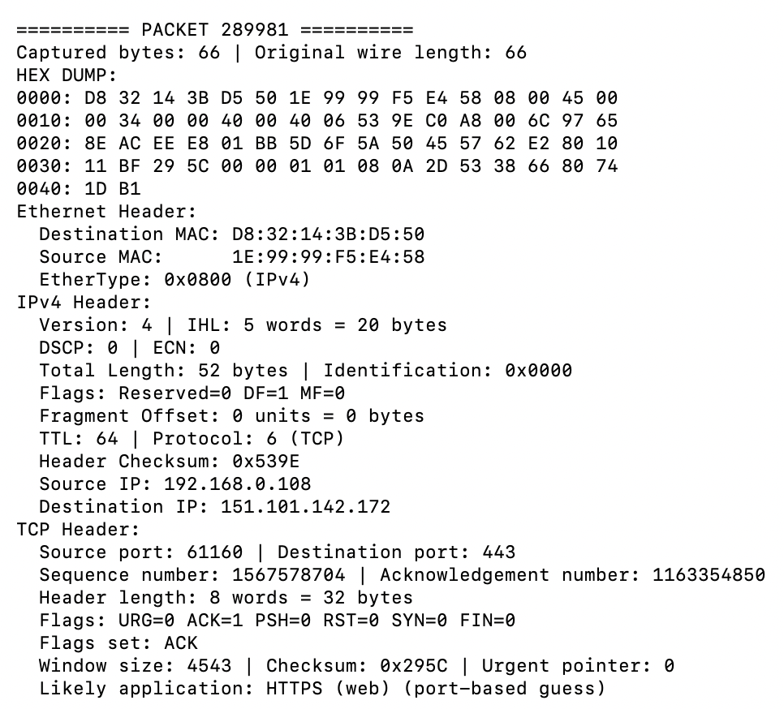
The TCP screenshot shows IPv4 protocol number 6. The packet has source port 61160 and destination port 443, and the ACK flag is set. Port 443 is commonly used for secure web traffic. This identification is based on the port number; it does not mean the sniffer has decrypted the contents.

6.2 UDP packet
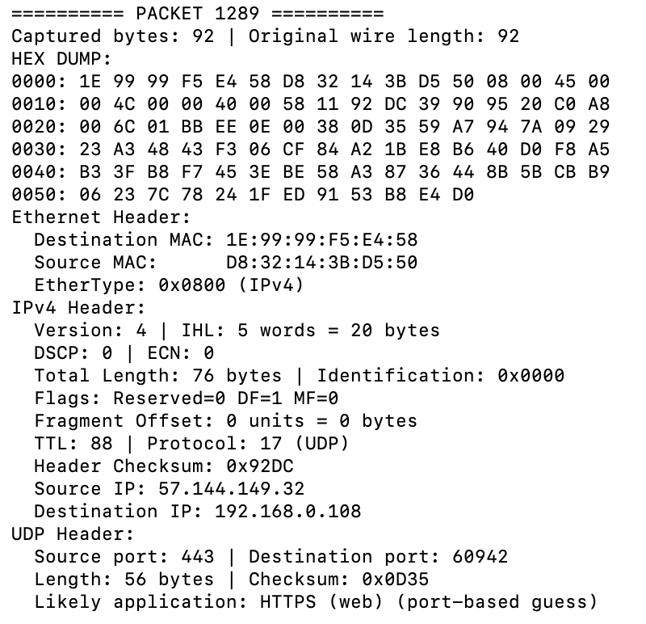
The UDP screenshot shows IPv4 protocol number 17, with source port 443 and destination port 60942. The UDP length and checksum also appear in the output. UDP port 443 may be used for HTTP/3 (QUIC), so the application name printed by the program is only a likely guess based on the port.

7. Conclusion
This assignment helped us understand how a packet is structured and how header values can be read directly from captured bytes. The program successfully displayed Ethernet, IPv4, TCP and UDP information from our own network traffic. The most important part was calculating the correct byte offsets and using bit operations instead of predefined protocol structures. We also learned that the sniffer must check packet lengths before decoding them.
We kept the capture limited to our own device. Before sharing or printing packet dumps, sensitive information in any captured payload should be removed. The full source code used for the capture is attached below.

Complete C Source Code
#include <pcap.h>
#include <stdio.h>
#include <stdlib.h>
#include <stdint.h>
#include <string.h>
#include <signal.h>

#define MAXBYTES 2048
#define ETHERNET_LEN 14

static pcap_t *capture_handle = NULL;
static unsigned long total_frames = 0, tcp_packets = 0, udp_packets = 0;

/* Read a 16-bit network-order (big-endian) field using only byte indexing. */
static uint16_t read16(const u_char *p)
{
return (uint16_t)(((uint16_t)p[0] << 8) | p[1]);
}

/* Read a 32-bit network-order (big-endian) field using only byte indexing. */
static uint32_t read32(const u_char *p)
{
return ((uint32_t)p[0] << 24) | ((uint32_t)p[1] << 16) |
((uint32_t)p[2] << 8) | p[3];
}

/* MEMBER 2: Hex dump and Ethernet decoding (enter member name).
* Print the complete captured packet as hexadecimal bytes FIRST. */
static void print_hex(const u_char *p, size_t n)
{
for (size_t i = 0; i < n; i++) {
if (i % 16 == 0) printf("%04zx: ", i);
printf("%02X ", p[i]);
if (i % 16 == 15 || i + 1 == n) putchar('\n');
}
}

/* MEMBER 4: Transport decoding and application guessing (enter name).
* Match either transport port to a commonly used application. */
static const char *application(uint16_t src, uint16_t dst)
{
uint16_t ports[] = {src, dst};
for (int i = 0; i < 2; i++) {
switch (ports[i]) {
case 80: return "HTTP (web)";
case 443: return "HTTPS (web)";
case 25: return "SMTP (email)";
case 20: case 21: return "FTP";
case 53: return "DNS";
case 22: return "SSH";
case 67: case 68: return "DHCP";
case 123: return "NTP";
default: break;
}
}
return "Unknown / non-standard port";
}

/* Decode TCP fields at transport offset (no struct tcphdr). */
static void parse_tcp(const u_char *p, size_t end, size_t start)
{
if (start > end || end - start < 20) {
puts("[TCP header incomplete / not captured]");
return;
}
uint16_t src = read16(p + start); /* Source port: bytes 0-1 */
uint16_t dst = read16(p + start + 2); /* Destination port: 2-3 */
uint32_t seq = read32(p + start + 4); /* Sequence number: 4-7 */
uint32_t ack = read32(p + start + 8); /* Acknowledgement: 8-11 */
unsigned words = p[start + 12] >> 4; /* TCP Data Offset: high nibble */
unsigned flags = p[start + 13]; /* TCP control bits: byte 13 */
if (words < 5 || end - start < words * 4U) {
puts("[Invalid or truncated TCP header]");
return;
}
printf("TCP Header:\n");
printf(" Source port: %u | Destination port: %u\n", src, dst);
printf(" Sequence number: %u | Acknowledgement number: %u\n", seq, ack);
printf(" Header length: %u words = %u bytes\n", words, words * 4);
printf(" Flags: URG=%u ACK=%u PSH=%u RST=%u SYN=%u FIN=%u\n",
!!(flags & 0x20), !!(flags & 0x10), !!(flags & 0x08),
!!(flags & 0x04), !!(flags & 0x02), !!(flags & 0x01));
printf(" Flags set:");
if (flags & 0x20) printf(" URG");
if (flags & 0x10) printf(" ACK");
if (flags & 0x08) printf(" PSH");
if (flags & 0x04) printf(" RST");
if (flags & 0x02) printf(" SYN");
if (flags & 0x01) printf(" FIN");
if (!(flags & 0x3F)) printf(" none of the classic six");
putchar('\n');
printf(" Window size: %u | Checksum: 0x%04X | Urgent pointer: %u\n",
read16(p + start + 14), read16(p + start + 16),
read16(p + start + 18));
printf(" Likely application: %s (port-based guess)\n", application(src, dst));
tcp_packets++;
}

/* Decode UDP fields at transport offset (no struct udphdr). */
static void parse_udp(const u_char *p, size_t end, size_t start)
{
if (start > end || end - start < 8) {
puts("[UDP header incomplete / not captured]");
return;
}
uint16_t src = read16(p + start); /* Source port: bytes 0-1 */
uint16_t dst = read16(p + start + 2); /* Destination port: 2-3 */
uint16_t len = read16(p + start + 4); /* UDP length: bytes 4-5 */
uint16_t sum = read16(p + start + 6); /* UDP checksum: bytes 6-7 */
if (len < 8) {
puts("[Invalid UDP length]");
return;
}
printf("UDP Header:\n");
printf(" Source port: %u | Destination port: %u\n", src, dst);
printf(" Length: %u bytes | Checksum: 0x%04X\n", len, sum);
printf(" Likely application: %s (port-based guess)\n", application(src, dst));
udp_packets++;
}

/* Process Ethernet first, then IPv4, then the matching transport protocol. */
static void process_pkt(u_char *args, const struct pcap_pkthdr *h,
const u_char *p)
{
(void)args; /* libpcap callback user data is not needed here. */
total_frames++;
printf("\n========== PACKET %lu ==========\n", total_frames);
printf("Captured bytes: %u | Original wire length: %u\n", h->caplen, h->len);
puts("HEX DUMP:");
print_hex(p, h->caplen);
if (h->caplen < ETHERNET_LEN) {
puts("[Ethernet header truncated]");
return;
}

/* MEMBER 2: Ethernet fields: dst [0..5], src [6..11], type [12..13]. */
uint16_t type = read16(p + 12);
const char *type_name = type == 0x0800 ? "IPv4" :
type == 0x0806 ? "ARP" :
type == 0x86DD ? "IPv6" : "Other";
puts("Ethernet Header:");
printf(" Destination MAC: %02X:%02X:%02X:%02X:%02X:%02X\n",
p[0], p[1], p[2], p[3], p[4], p[5]);
printf(" Source MAC: %02X:%02X:%02X:%02X:%02X:%02X\n",
p[6], p[7], p[8], p[9], p[10], p[11]);
printf(" EtherType: 0x%04X (%s)\n", type, type_name);
if (type != 0x0800) {
puts(" Not IPv4; no IPv4/TCP/UDP decoding for this frame.");
return;
}

/* MEMBER 3: IPv4 decoding (enter name).
* IPv4 begins immediately after the 14-byte Ethernet header. */
size_t ip = ETHERNET_LEN;
if (h->caplen < ip + 20) {
puts("[IPv4 base header truncated]");
return;
}
unsigned version = p[ip] >> 4; /* Version: high nibble */
unsigned ihl = p[ip] & 0x0F; /* IHL: low nibble */
size_t ip_bytes = (size_t)ihl * 4; /* IHL units are 32-bit words */
if (version != 4 || ihl < 5 || ip_bytes > h->caplen - ip) {
puts("[Invalid or truncated IPv4 header]");
return;
}
uint16_t total = read16(p + ip + 2); /* Total Length: bytes 2-3 */
uint16_t ident = read16(p + ip + 4); /* Identification: 4-5 */
uint16_t frag = read16(p + ip + 6); /* Flags + fragment offset: 6-7 */
unsigned fragment = frag & 0x1FFF; /* Offset is 13 bits / 8-byte units */
unsigned proto = p[ip + 9]; /* Protocol number: byte 9 */
if (total < ip_bytes) {
puts("[IPv4 Total Length is smaller than the IP header]");
return;
}
const char *proto_name = proto == 6 ? "TCP" :
proto == 17 ? "UDP" : "Other";
puts("IPv4 Header:");
printf(" Version: %u | IHL: %u words = %zu bytes\n", version, ihl, ip_bytes);
printf(" DSCP: %u | ECN: %u\n", p[ip + 1] >> 2, p[ip + 1] & 3);
printf(" Total Length: %u bytes | Identification: 0x%04X\n", total, ident);
printf(" Flags: Reserved=%u DF=%u MF=%u\n",
!!(frag & 0x8000), !!(frag & 0x4000), !!(frag & 0x2000));
printf(" Fragment Offset: %u units = %u bytes\n", fragment, fragment * 8);
printf(" TTL: %u | Protocol: %u (%s)\n", p[ip + 8], proto, proto_name);
printf(" Header Checksum: 0x%04X\n", read16(p + ip + 10));
printf(" Source IP: %u.%u.%u.%u\n",
p[ip + 12], p[ip + 13], p[ip + 14], p[ip + 15]);
printf(" Destination IP: %u.%u.%u.%u\n",
p[ip + 16], p[ip + 17], p[ip + 18], p[ip + 19]);
if (fragment != 0) {
puts(" Non-first IPv4 fragment: transport header not present; skip.");
return;
}

/* MEMBER 4: Find the TCP/UDP offset and decode transport header.
* Bound by BOTH captured bytes and IPv4 Total Length. */
size_t end = ip + total;
if (end > h->caplen) end = h->caplen;
size_t trans = ip + ip_bytes; /* Uses IHL; never assumes IP=20. */
if (proto == 6) parse_tcp(p, end, trans);
else if (proto == 17) parse_udp(p, end, trans);
else puts(" Transport: not TCP or UDP.");
}

/* Stop cleanly so totals and pcap statistics can be printed. */
static void stop_capture(int signum)
{
(void)signum;
if (capture_handle != NULL) pcap_breakloop(capture_handle);
}

int main(int argc, char **argv)
{
char errbuf[PCAP_ERRBUF_SIZE] = {0};
char *device;
if (argc > 2) {
fprintf(stderr, "Usage: %s [network-interface]\n", argv[0]);
return 1;
}
/* MEMBER 1: Device selection and capture setup (enter member name).
* Module 1: explicit device argument or pcap_lookupdev(). */
device = argc == 2 ? argv[1] : pcap_lookupdev(errbuf);
if (device == NULL) {
fprintf(stderr, "No capture device: %s\n", errbuf);
return 1;
}
/* Module 2: open device, snapshot 2048 bytes, promiscuous=1, timeout=1000ms. *
capture_handle = pcap_open_live(device, MAXBYTES, 1, 1000, errbuf);
if (capture_handle == NULL) {
fprintf(stderr, "pcap_open_live failed: %s\n", errbuf);
return 1;
}
if (pcap_datalink(capture_handle) != DLT_EN10MB) {
fprintf(stderr, "Interface %s is not Ethernet (DLT_EN10MB). "
"Choose an Ethernet-style interface, not any.\n", device);
pcap_close(capture_handle);
return 1;
}
printf("Listening on %s (Ctrl+C to stop). Capture only your own traffic.\n", device);
signal(SIGINT, stop_capture);
/* Module 3: pcap_loop calls process_pkt for each packet; -1 = continuous. */
int result = pcap_loop(capture_handle, -1, process_pkt, NULL);
if (result == PCAP_ERROR) fprintf(stderr, "Capture error: %s\n", pcap_geterr(capture_handle));
/* Module 4: print callback counters + kernel capture statistics; clean up. */
printf("\nFrames seen by callback: %lu | Decoded TCP: %lu | Decoded UDP: %lu\n",
total_frames, tcp_packets, udp_packets);
struct pcap_stat statistics; /* libpcap statistics, NOT a protocol header. */
if (pcap_stats(capture_handle, &statistics) == 0)
printf("libpcap received: %u | Dropped: %u\n",
statistics.ps_recv, statistics.ps_drop);
pcap_close(capture_handle);
return result == PCAP_ERROR ? 1 : 0;
}

